This document covers all Wastepack Group packaging compliance schemes. This is the ‘Full’ Members online guide for the annual data submissions and will assist you with your data submission.
The system has been set up to enable our Members to submit data quickly and with ease. We will also be able to review the data more quickly and identify any potential issues or problems.
The following guide refers to Members and explains how to use the system from first logon through to final data submission.
Please note that there is also an online guide for ‘Small Producers’ Members of the scheme and a ‘Quick Start’ guide.

Using the Online submission system
To access the Wastepack online submission site, please type in www.wastepack.co.uk and then select the ‘Members Login’ in the top right hand corner which will show a drop down menu. From there please select ‘Annual Packaging Return’, as shown in the screen shot below.
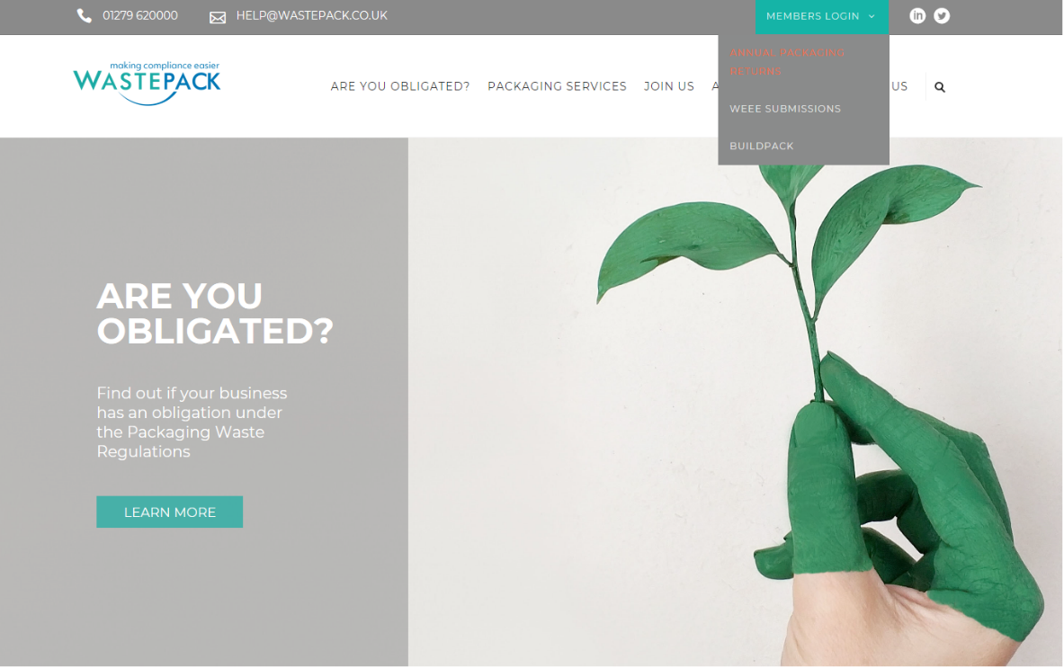

Logging onto the website
You will then be presented with a logon screen, which is shown in the next screen shot.
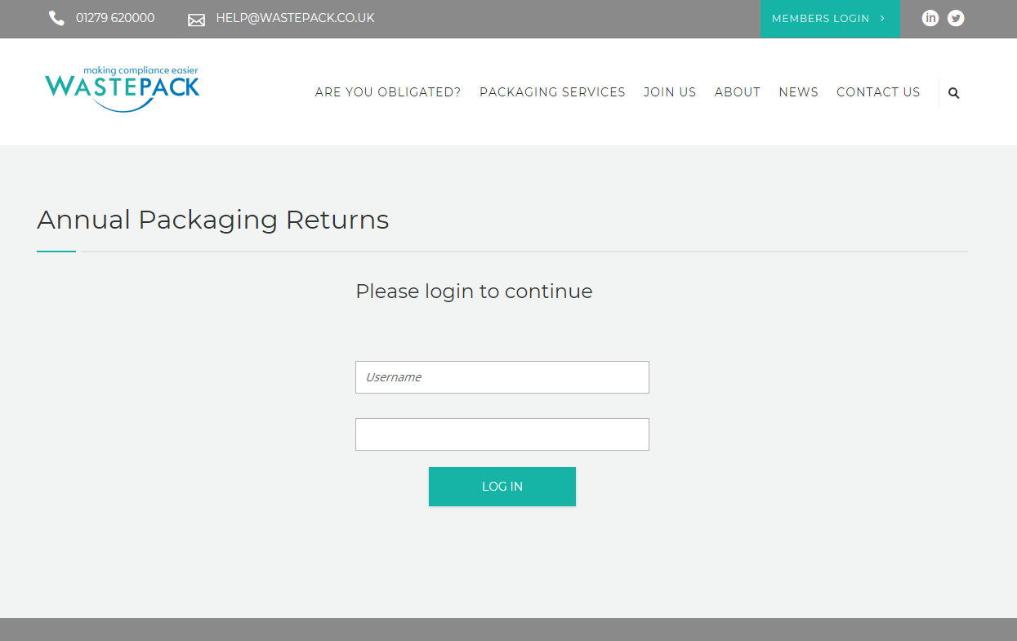
The username and password will have been provided to you by a Wastepack administrator. Please enter these into the relevant fields and select the “Login” button.
Once the password has been accepted by the website, you will arrive at the welcome page. At this point, click on the ‘Continue to Returns Form’ button.
Your statement of obligation will be available from the welcome page from May. Select the ‘Continue’ button under ‘Statement of Obligation’.

Rules for submitting Data
The website has been set up to accept data submissions from 1st February through to 30th November each year. This is in line with the Agencies request for receiving data and resubmissions throughout the year.
Please note that we require all data to be submitted by the end of February each year.
Any resubmission information can be accepted throughout the year after the middle of April.
The online system will not be available from 1st December to the 31st January. This is a necessity because of the Agencies year end.
If you do have any resubmission queries during these times, please contact the Compliance team on 01279 620000.

The Online form
When you have logged onto the online form, you will see the help guides just under the Wastepack logo. These will be available regardless of the tab you are in. Please note that these files are in PDF format.
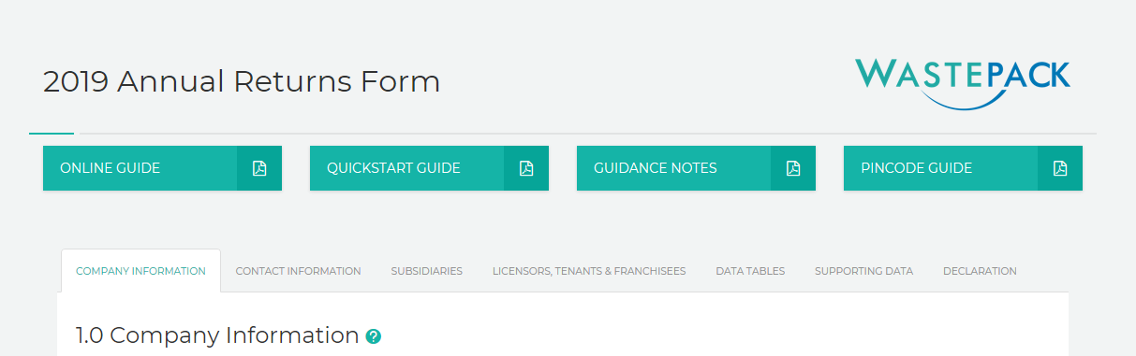
A copy of the data guidance notes will also be available on the online form if you need to print a copy.

Guidance Notes and Help Bubbles
The online submission is full of guidance notes and help bubbles to assist you with your data submission.
These appear as a white question mark in a green bubble.
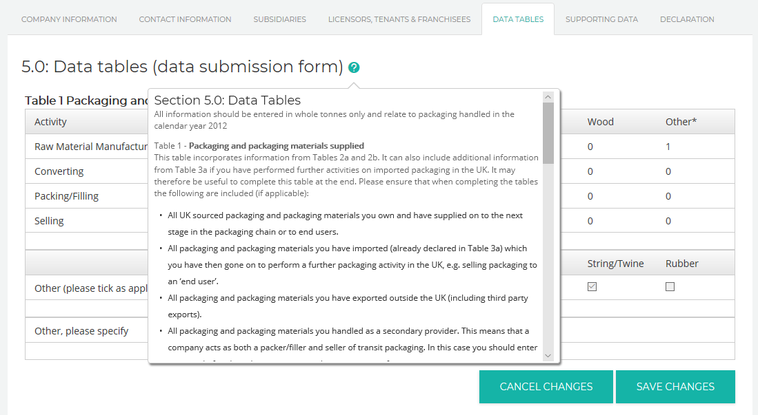
Once clicked on, a pop up box appears displaying the relevant guidance notes for that section.

Saving the Data Form information
There are three save options on the online submission. The first two are available on the first six tabs. These are ‘Save and Continue’ and ‘Save Progress and Logout’.
‘Save and Continue’ saves the current tab in its current state and then moves the submission to the next tab.
‘Save Progress and Logout’ again saves the current tab in its current state and then logs you out of the system, returning to the log in screen.
The last save option is ‘Save and Submit’. This is found on the ‘Declaration’ tab only. This will be explained in greater detail in a later section.
There are seven tabs on the online form and all of these will need to be completed before you can submit your data. The tabs are –
- Company Information
- Contact Information
- Subsidiaries
- Licensors, Tenants and Franchisees
- Supporting Data
- Declaration
The seven tabs cover all of the information that is required by the relevant Agency to complete your submission.
The next section of this guide details each of the seven tabs individually.

‘Company Information’ tab
The ‘Company Information’ tab is the first on the form and is section 1.
Please note that a number of fields have been ‘greyed out’. These fields can only be amended by Wastepack staff. If you need to change sections 1.1, 1.2, 1.4 or 1.5 please contact our Compliance team on 01279 620000. Section 1.9 is your unique NPWD code which is supplied by the Agency. This code cannot be changed and will remain with your organisation throughout its lifetime. The remaining fields can all be amended when carrying out a submission.
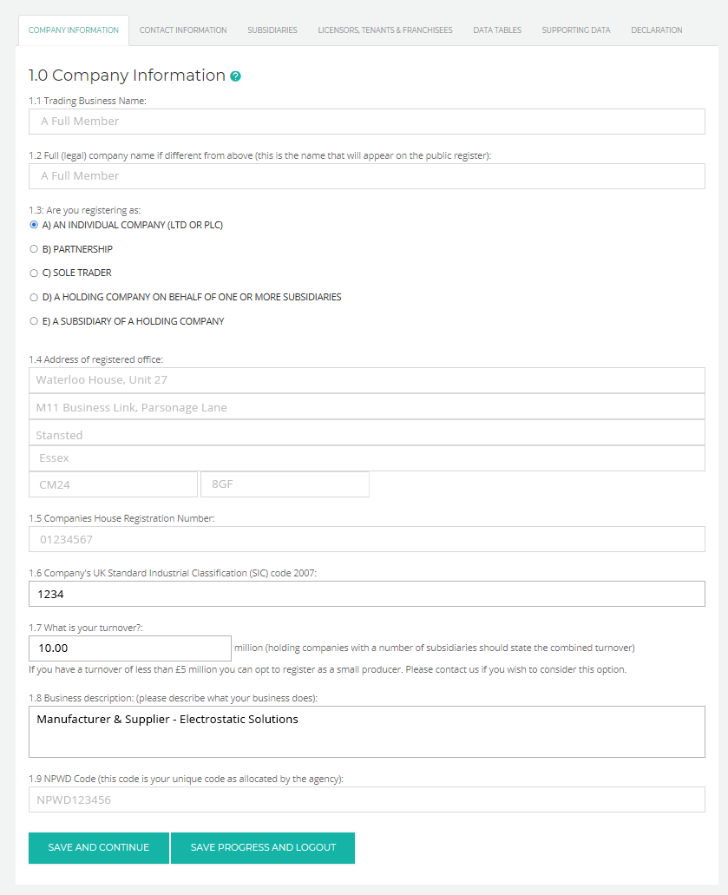
To ensure your data is saved please move onto the next tab by clicking the ‘Save and Continue’ button.

‘Contact Information’ tab
The second tab is ‘Contact Information’. It is compulsory that a main contact, secondary contact and contact address is filled in.
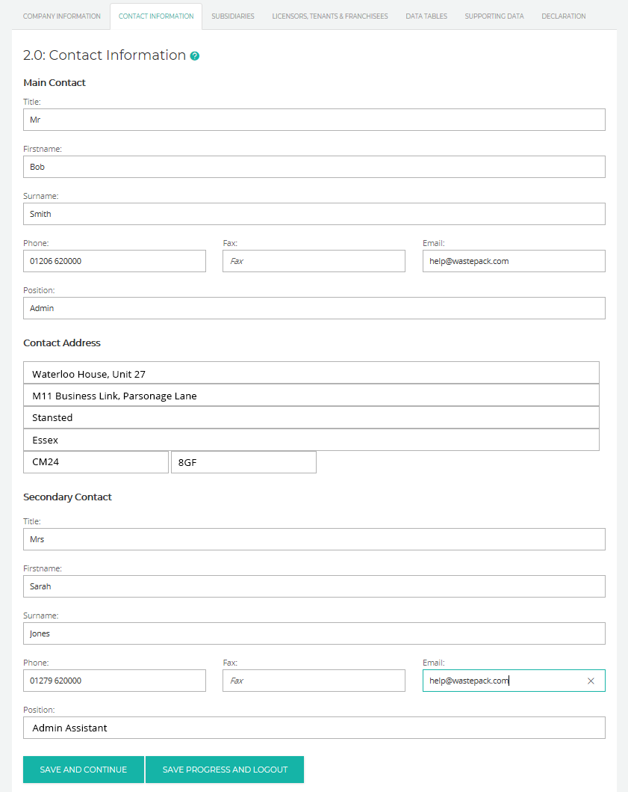

‘Subsidiaries’ tab
Members who do not have obligated subsidiaries must ensure that they tick the box as displayed below –
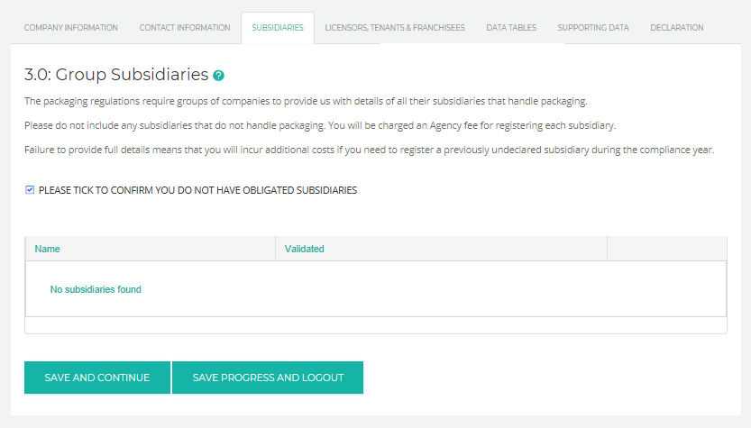This field is part of the online submissions validation and must be completed.
Members who have obligated subsidiaries that have been declared will automatically appear on the online submission when they are logged in.
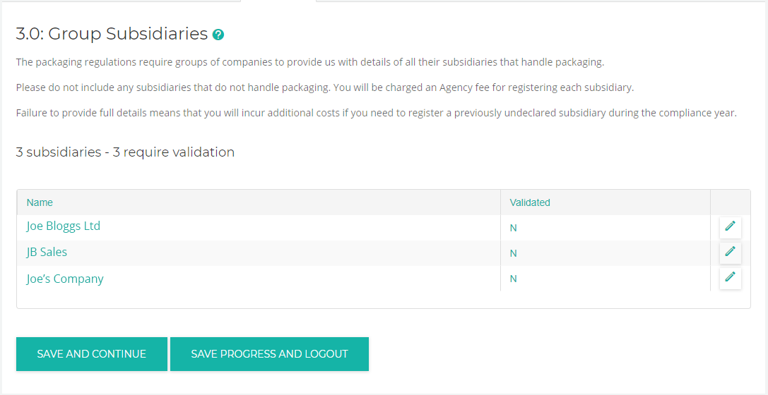Each subsidiary must be validated by the Member. Select the ‘Edit’ option for each subsidiary. The full details will appear across the rest of the screen (sections 3.1 to 3.9).

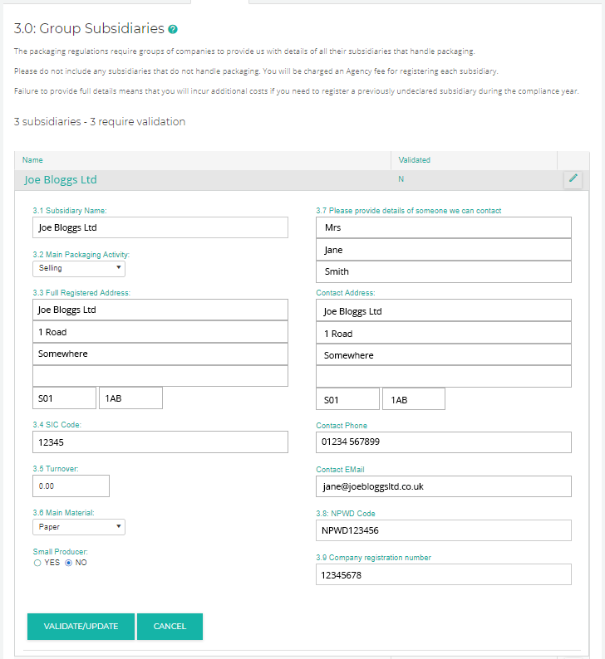

Ensure all of the subsidiary information is completed and correct and then click on the ‘VALIDATE/UPDATE’ option.
If you are viewing a subsidiary and have incorrectly or accidently made a change, select the ‘Cancel’ option at the bottom and this will close the subsidiary without making any changes.
Please note that if you do not validate the subsidiaries then you will be unable to submit to us as it will fail the overall validation.
If you need to add or remove a subsidiary from your submission please contact our Compliance team on 01279 620000.

‘Licensors, Tenants and Franchisees’ tab
There are two parts to the ‘Licensors, Tenants and Franchisees’ tab. The example below shows a Member who does not have any licensors.
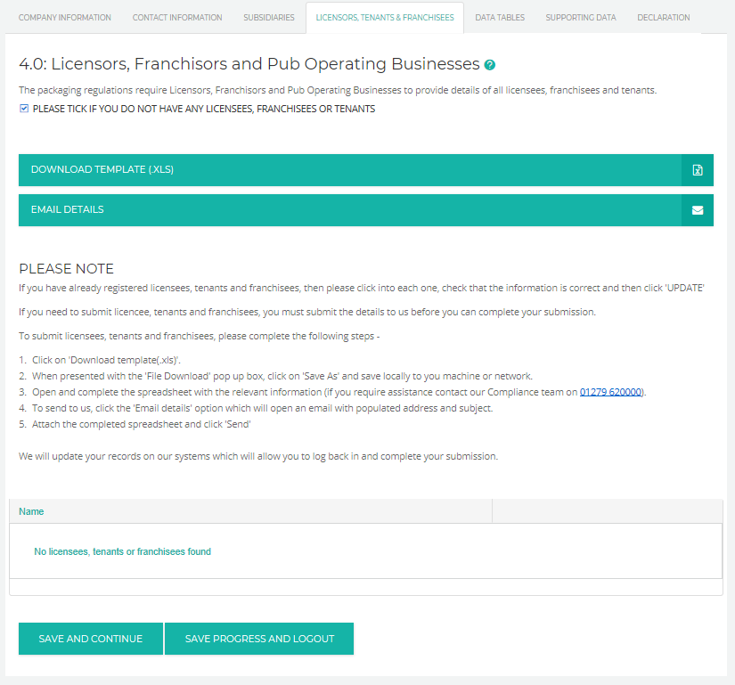
To confirm that you do not have any licensors, tenants or franchisees, then you must tick the box.
If you do have licensors, tenants or franchisees, then you must download the Excel template and complete the details on it. These are required by the Agency. The spreadsheet is downloaded by clicking on the ‘Download template (.xls)’ link.
Once you have completed the form you can then email it to us by clicking on the email link. This will open a new email message with the address and subject header already completed. Please attach your form to this email and send it to us.
If you have already submitted licensors to us then they will automatically appear on the tab. Please check through each of these licensors to ensure that the information is correct. If anything is not, please amend on the website.

Members who have licensors will see a screen similar to that below. The tick box will disappear and each of the licensees will be listed. To view each one, click on the ‘Edit’ option. If anything is amended, click ‘VALIDATE/UPDATE’ or ‘CANCEL’ to return to the main list.

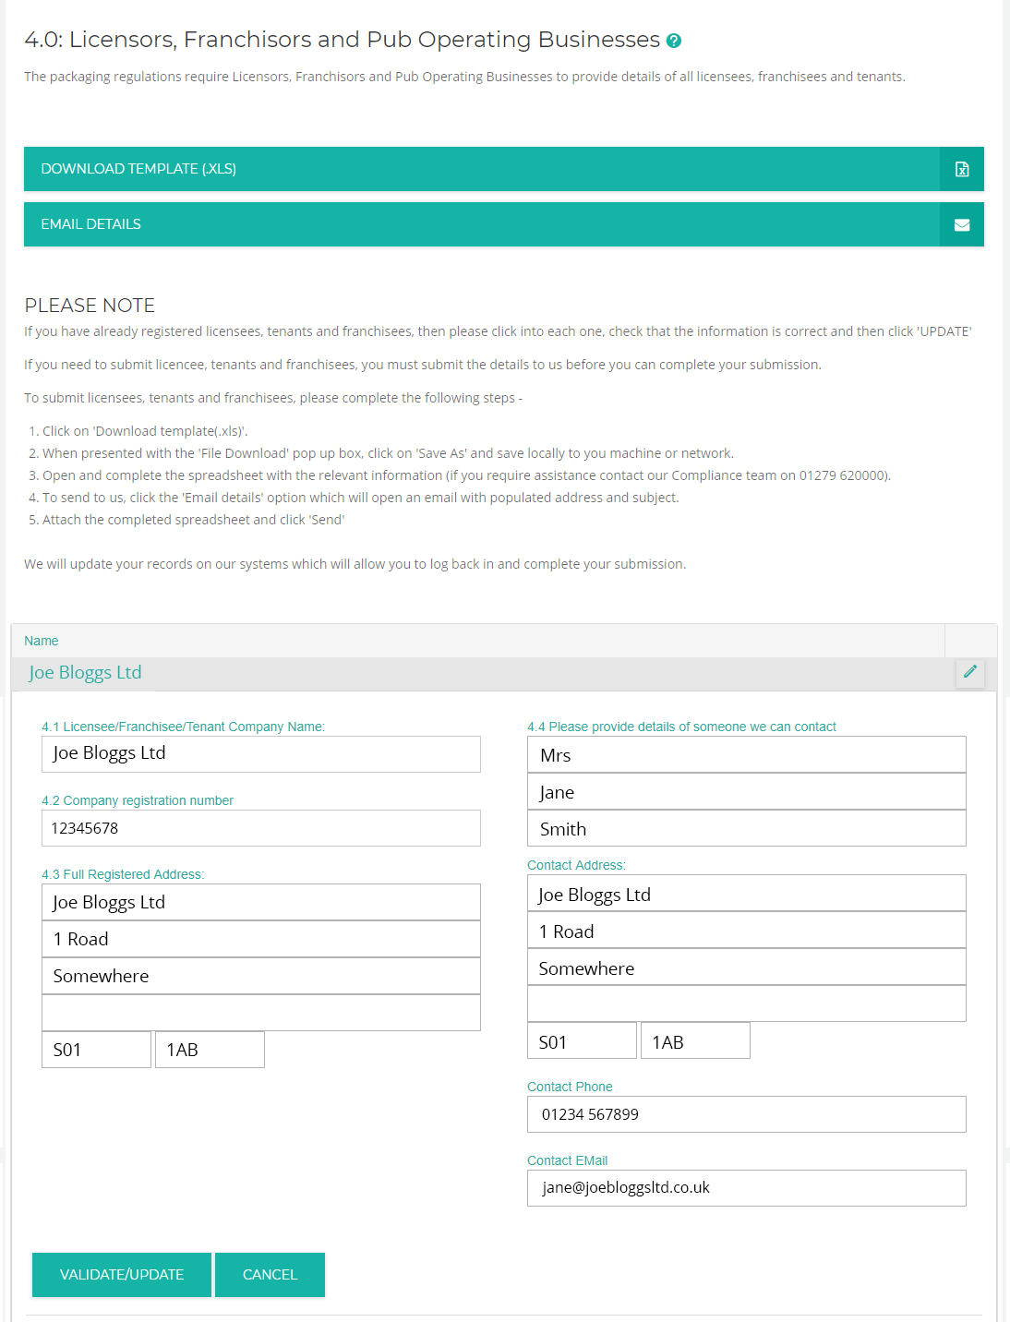

‘Data Tables’ tab
This tab is where you need to record your packaging data from the previous compliance year. Please ensure that all figures are entered.
An example of how this screen will look is below –
[Data Tables Continued on Next Page…]
[Data Tables Continued…]
To make a change to any of the figures within the data tables, select the figure and type in the new data to amend it.
Make the changes to the figures for each table. If you do not wish to save the changes, click ‘Cancel Changes’ under the table you are editing. If the changes are correct, click ‘Save Changes’ under the table you are editing.
Do this for each table on the form.

The same applies to sections of the data tab that needs either ticking or text. For the ‘Other’ sections, make the necessary changes and click ‘Save Changes’. Please note that you will need to click on the ‘Other’ section of the table (highlighted below) to open the check boxes for editing.
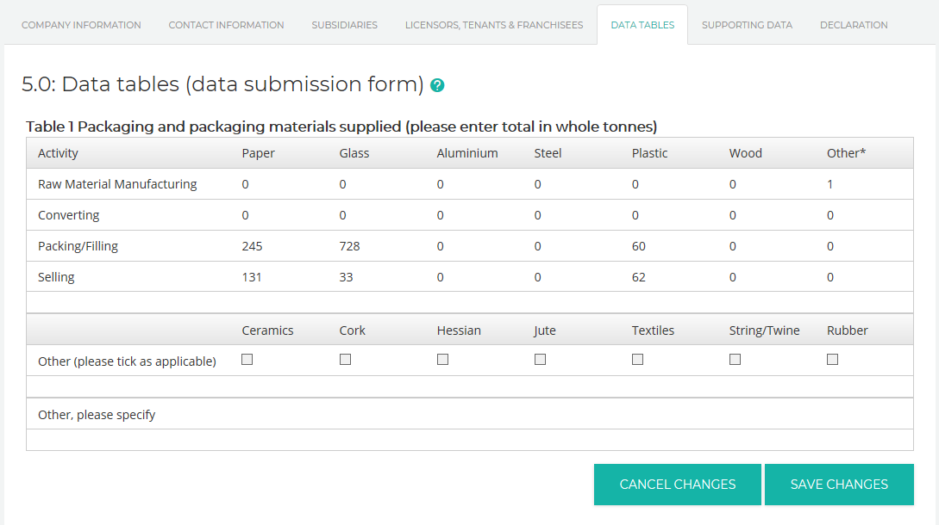
When you hover over any of the figures in tables 2a through to 3c, a help feature appears on the right hand side of the web page with guidance information.
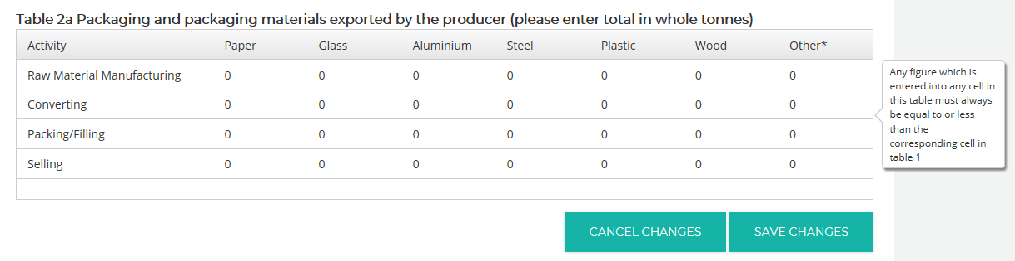

‘Supporting Data’ tab
This tab is important to the submission as it asks questions that will assist us in understanding your data and ensuring that it is correct. This information is also important to the relevant Agencies.
[Supporting Data Continued on Next Page…]

[Supporting Data Continued…]

The questions in section 6 are all compulsory. However:
Section 6.3 will activate and ask you to confirm your export evidence ONLY if you declare any exports on the Data Tables tab.
6.6 has been greyed out as the system will work out your main and secondary activities automatically.
Section 6.7 also has some rules. These are as follows –
- ‘Supplier Data’, ‘Sample Weighing’ and ‘Sales Records’ – A MINIMUM OF ONE OF THESE MUST BE SELECTED.
- ‘Trade Association Methodology’, ‘Other’ and ‘Do you use a third party to calculate your data’ – These are all OPTIONAL.
- The TEXT BOXES for ‘Trade Association Methodology’, ‘Other’ and ‘Do you use a third party to calculate your data’ questions are only compulsory when the tick box has been selected.
When you log on to the website, the answers to the questions are set as blank. Please ensure that you read each question and answer correctly.
Section 7 is another crucial element to the form and is compulsory. It is essential that you detail why there are differences in the data compared to the previous compliance year. This helps us when we check the data as we do compare to previous years submissions. The various Agencies also review this when they carry out audits.
The last part of this tab is section 8, Agency Audits. The first part is the last date that an Agency audit was carried out. Please complete this so we can update our records. If you select ‘Yes’ a calendar will appear with the current days date selected. To move around the calendar use the left and right arrows or click on the top date for more date options. The date can also be entered by using the standard dd/mm/yy format.
The second part to this section is the address where an audit would be carried out. This is compulsory as we need this information for your submission.

Declaration
The final tab on the online submissions is ‘Declaration’. This tab carries general information as well as the place to upload your signature file or enter your pin code for the final submission of your return. Section 9 of the form is the ‘Data Protection Notice’ and is followed by six other sub sections. These can be viewed by clicking on the header. The final section (10) of the form is the declaration. 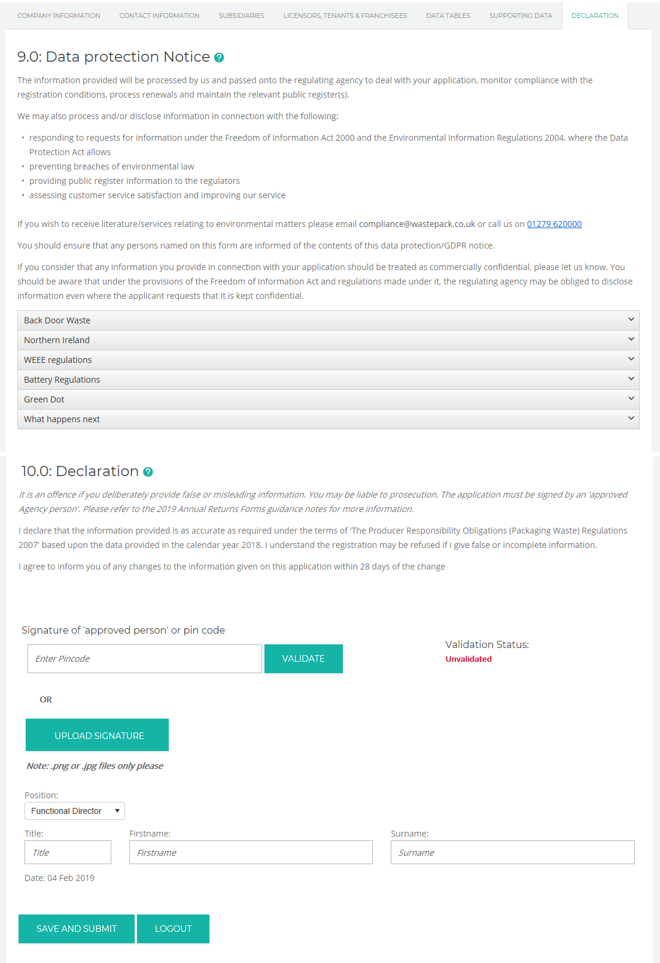

Authorising the Form – digital signature or pin code
The Agencies now accept digital signatures or a pin code in lieu of an authorised signature. All online submissions must be submitted with a digital signature or by entering your pin code. The submission is either or. You only need to complete one or the other.

Entering a pin code
To authorise your submission via pin code, you must request a pin code from Wastepack via an Agency approved person. Therefore, we require a letter from a Director, Company Secretary, Partner or Proprietor requesting a pin code. The letter must be on your company letterhead.
The pin code is entered on the final ‘Declaration’ tab and is carried out as follows –
On the ‘Declaration’ tab you need to complete the ‘Title’, ‘First Name’ and ‘Last Name’ as well as selecting the position of the relevant person who is authorising the submission and who the pin code is allocated to. This will be an active company director. Once you have entered the pin code, click on the ‘validate’ field to the right of the box. 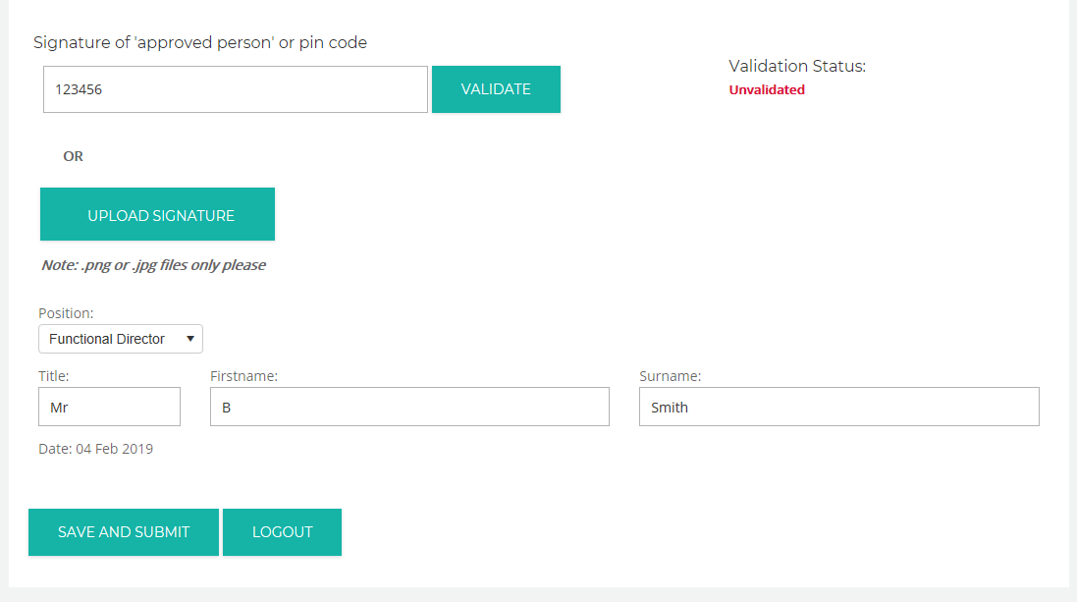
If the code has been entered incorrectly, the following message will appear –
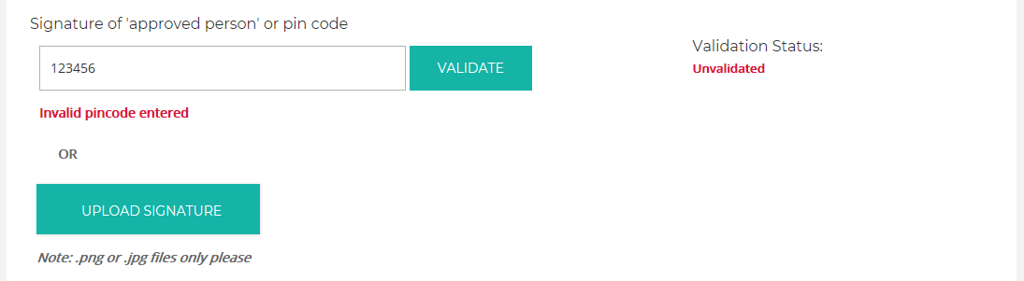

You will need to re-enter the pin code and try again. If the code is valid, then this will be confirmed within the ‘Validation Status’ box, as below.
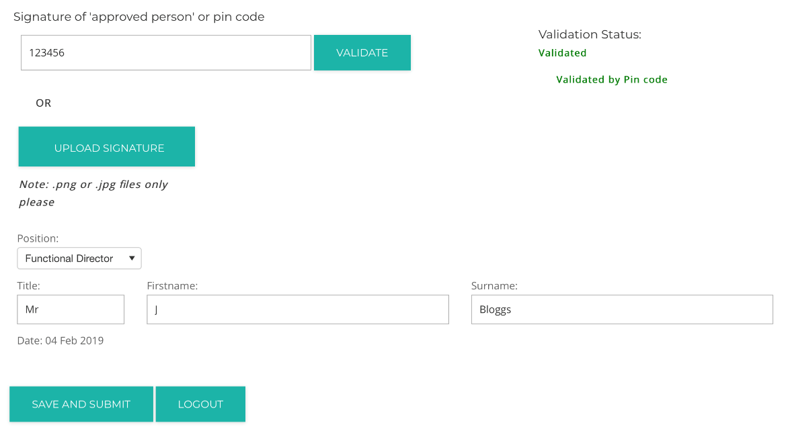
To finish please click on ‘Save and Submit’ to ensure the pin code is saved.

Uploading a digital signature
We request that digital signatures are uploaded in PNG (.png) or jpeg (.jpg) format. Any other format will be rejected.
The signature is uploaded on the final ‘Declaration’ tab and is carried out as follows –
On the ‘Declaration’ tab you need to complete the ‘Title’, ‘First Name’ and ‘Last Name’ as well as selecting the position of the relevant persons signature from the drop down menu.
To upload the signature file, click on ‘Upload Signature’. This allows you to search for the signature file on your machine.
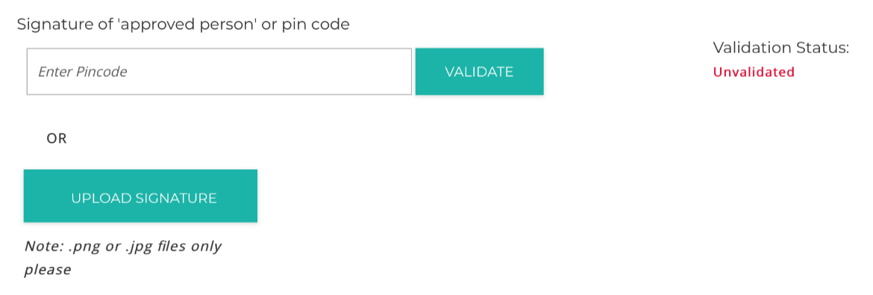

The file is then uploaded into the online submission and will appear on screen.
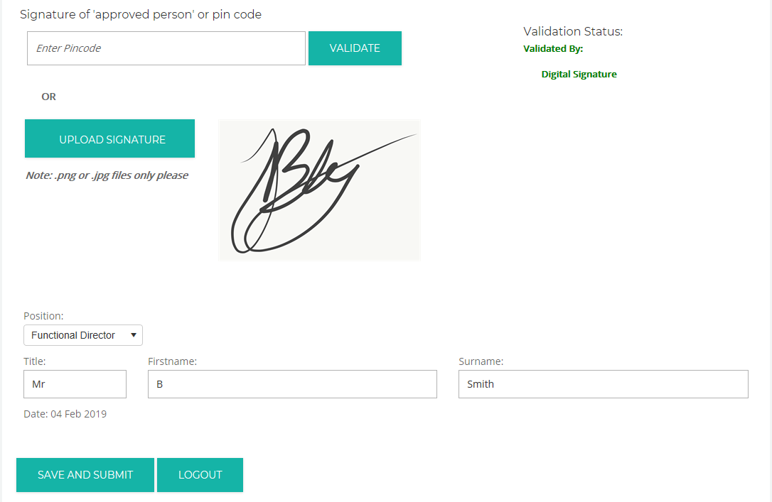
When the signature has been successfully added to the submission, this will be reflected within the ‘Validation Status’ field. The signature file is confirmed as valid.

Printing and Submitting the Form
Once you have completed your submission and uploaded the relevant persons digital signature the form can be submitted by clicking ‘Save and Submit’
This will check the entire form and ensure that all the compulsory fields have been completed. If any compulsory fields are missing they will be listed.
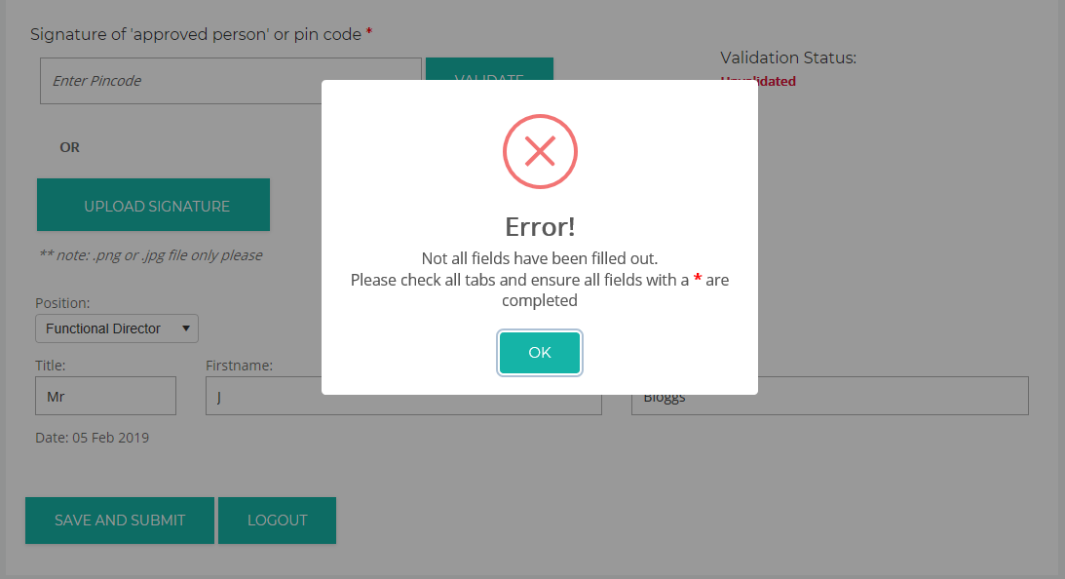
Please note that a return cannot be submitted until all the compulsory fields have been completed and the digital signature added.
Once you click on ‘Save and Submit’ the button will change to ‘Submitted’
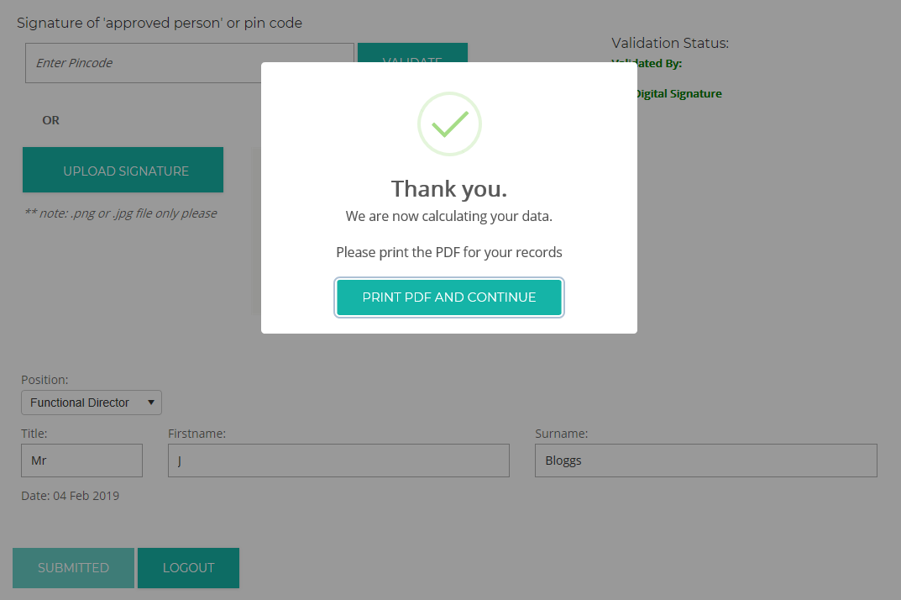

Your data has then been submitted to us!
Please ensure that you click ‘Print PDF’ at the end of the submission. This allows you to save the PDF file and/or print a copy. You will need this for your records.

Please note that by submitting online with a digital signature or pin code we do not require your completed form to be sent to us via the post.

Please note that we cannot accept your data unless the signature is valid or a pin code has been requested from an Agency approved person. The signature file must be that of a Director, Company Secretary, Partner or Proprietor.
Please ensure that your data is submitted by the 28th February 2022.

Troubleshooting
Please note that there is a ‘time out’ on the online submission. If there is a period of inactivity the site will disconnect. Therefore, please ensure that you save frequently.
If you have any other technical issues, please contact the Compliance Team on 01279 620000 or via compliance@wastepack.co.uk

